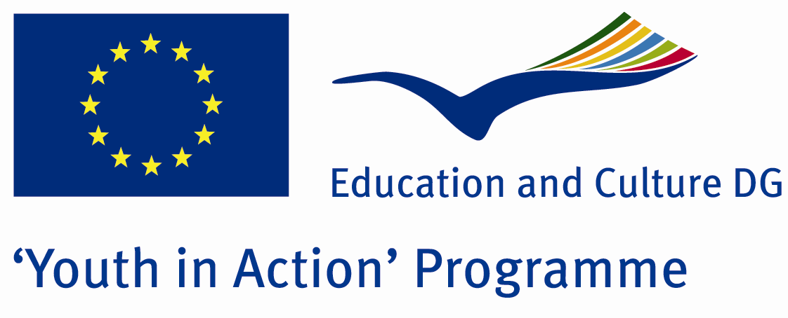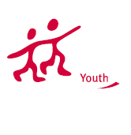

Don’t Kill Our Youth

ACTION 4.3 – Training And Networking

20-27th July, 2011

Mugla, TURKEY

ACTION 4.3 – Training And Networking
20-27th July, 2011
Mugla, TURKEY

Please contact directly to;
adventurerpeacepigeons@gmail.com

Project Summary;

According to United Nations reports, there are over 200 millions people who are using drugs in thw world and it is getting more %8 percent of it every year.Most of them are between 13- 30 ages. Every year, thousands people are dieing because of drugs..and The World of Drugs is bigger than many countries.Drugger youngsters have short and fake lives.but they dont know this and one day they loose their life in a hole…It is so dangerous for our future life and the world…We are living in a global world anymore…So this problem is all of us…For this aim, we want to make a Project about drugs…its damages?how can we save us and our families, friends agains th drugs?

Project Title; Don’t Kill Our Youth

Date and Venue ; 20-27th July, 2011 Mugla, Turkey .

Target Group ; Municipalities, City Councils and Non-Governmental organizations,
youth groups,culture and art groups,e.t.c

Participants ; 5 people from each country (over 18 -25 ). Totally 8 countries.

Conditions ; Accommodation, board and programme costs will be financed through European Commission Youth in Action Programme (Action 1.1). Travel costs will be reimbursed in 70% (APEX Tarrifs). Organizations from all 27 EU member countries plus Liechtenstein , Norway and Iceland are eligible to take part.

Working language: English

Organizer; Adventurer Peace Pigeons

How to apply: If you are interested, please send your Part III forms to
0090 216 494 39 98 by FAX please. (Fulfilled Part III which you can find in the attachment, of course signed and stamped) ..

Note: jpeg is not allowed..please send by fax…

Next step 2;
Original send via regular post to this address please:

Ertan DERİN
Öner İnşaat
Abdulhalik Renda Cd.
Parlar Sk. No:4 Pendik/İSTANBUL

If you have any questions you may contact with: adventurerpeacepigeons@gmail.com

Deadline for application; until 20 March 2011.

For Further information:
Contact Person
Ertan DERİN
Öner İnşaat
Abdulhalik Renda Cd.
Parlar Sk. No:4 Pendik/İSTANBUL

e-mail : adventurerpeacepigeons@gmail.com
Mobile : 0090 542 393 93 90
Fax : 0090 216 494 39 98

